Working on ADT: (Hands On)

Create Table Persistence and Generate Data:

* **How to create an ABAP package**
* Open ABAP Development Tools (ADT) and select your ABAP Cloud Project you created in Create an SAP BTP ABAP Environment Trail user

Right-click on ZLOCAL and select New > ABAP Package.

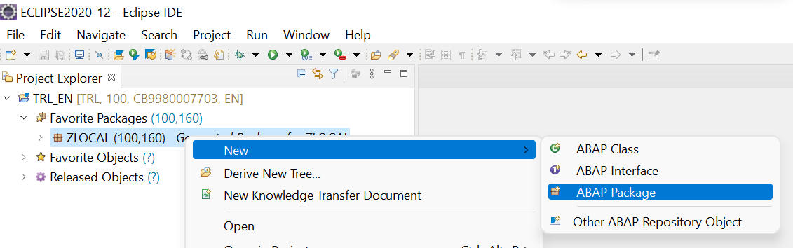

* Create a new ABAP package:
  + Name: ZCAPG_BTP1
  + Description: Package for creating travel app example
  + Superpackage : ZLOCAL
  + Check Add to favorite packages.

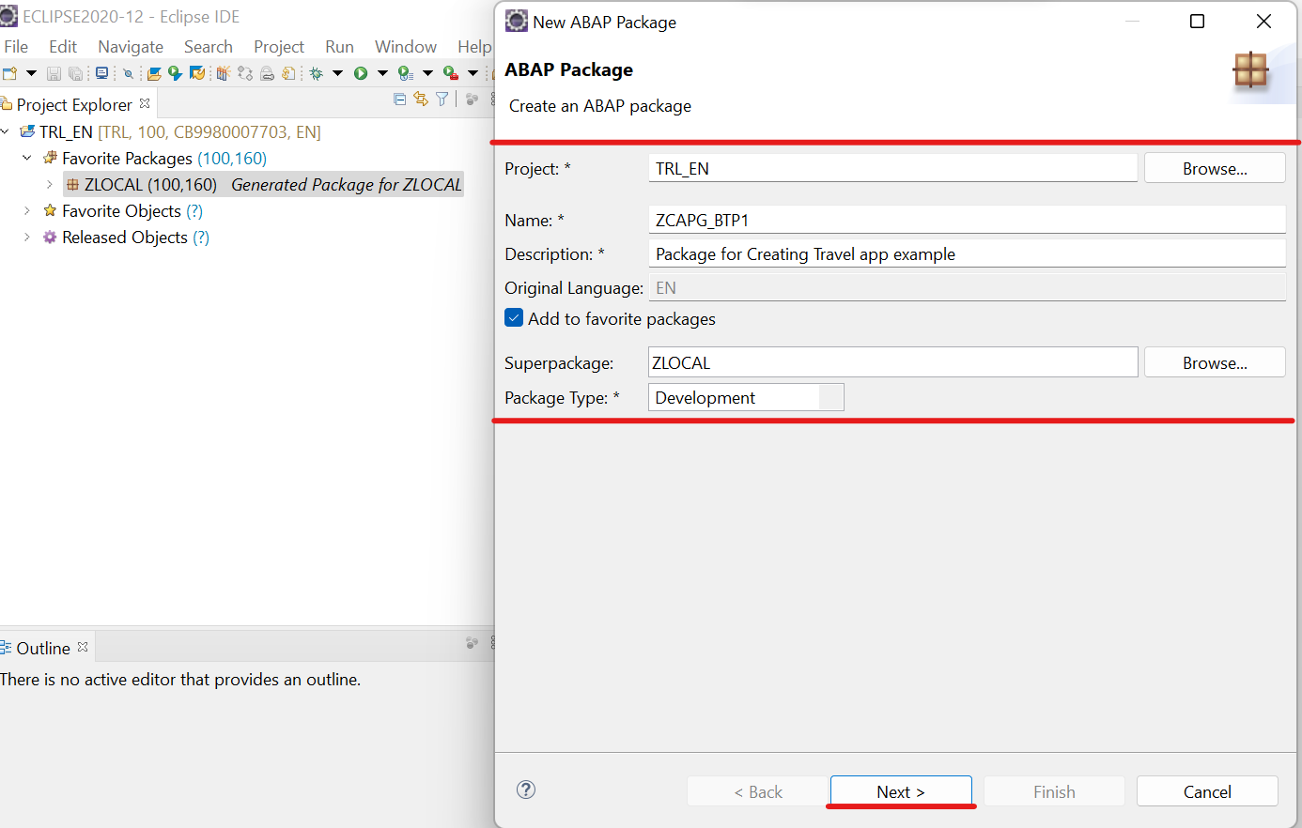

Click Next >.

* Select Create new request and enter a request description.

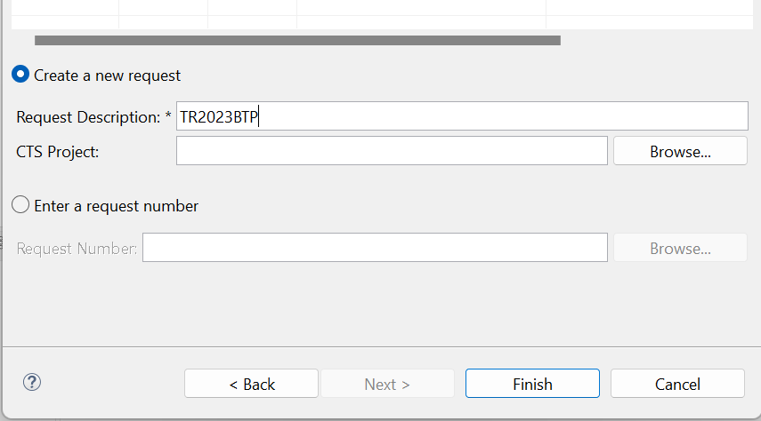

Click Finish.

* Now your package is added to favorites objects.

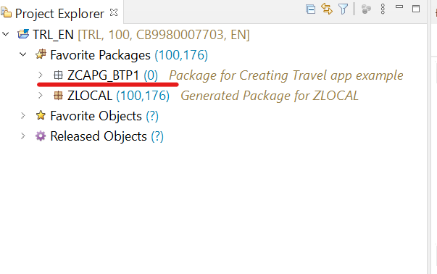

* **How to create a Data Base Table:**
* Right-click on your package ZCAPG_BTP1 select New > Other ABAP Repository Object.

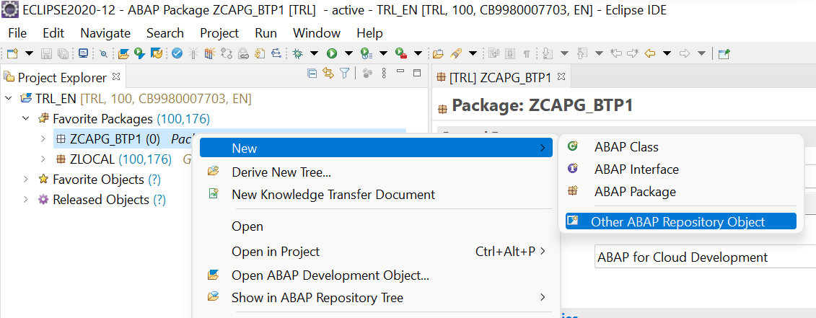

* Search for database table, select it and click Next >.

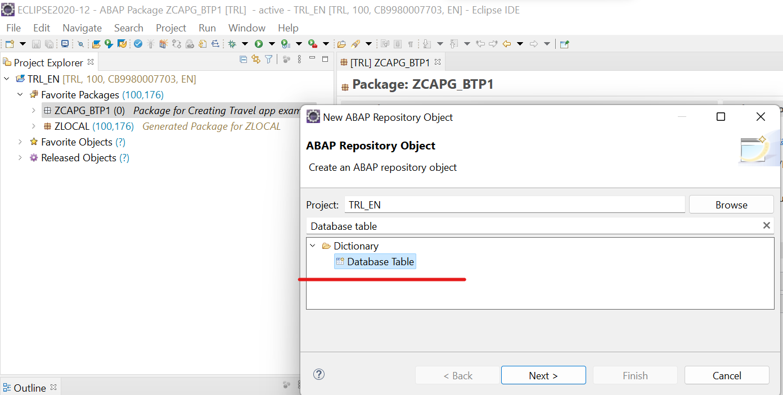

* Create a new database table:
  + Name: ZCAPG_TABLE1
  + Description: Table for travel data

Click Next >.

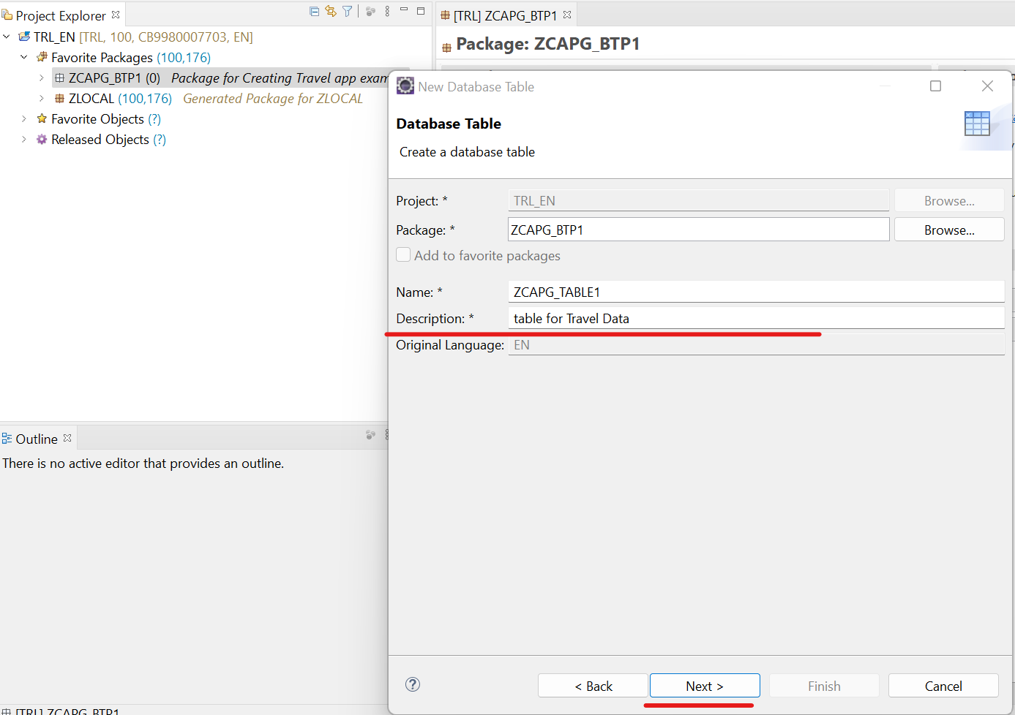

* Click Finish to create your transport request.

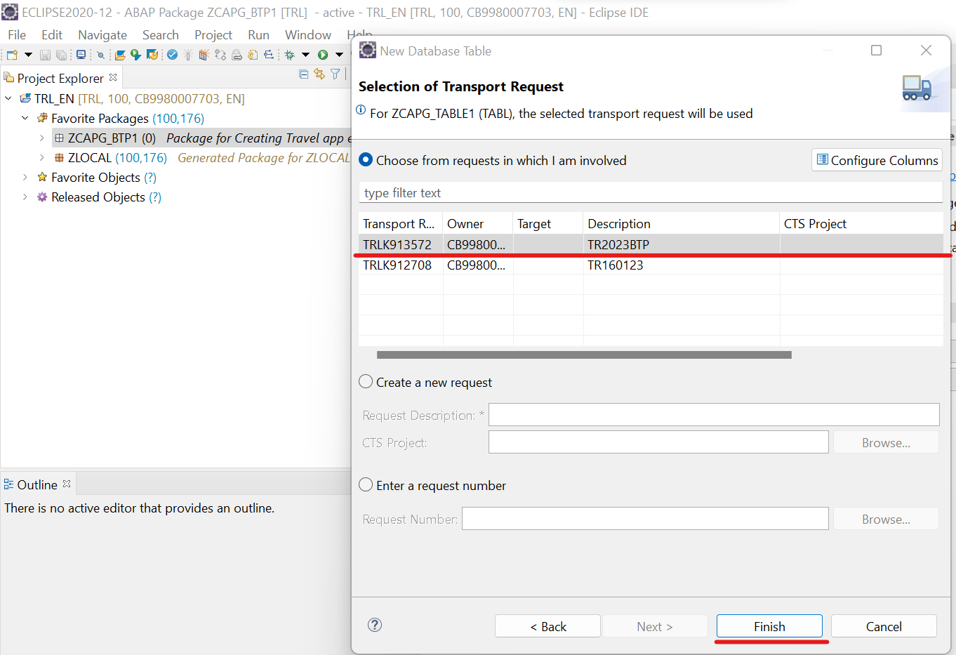

* Write the code for creating a database table:

**define** **table** zcapg_table1 **{**

**key** client **:** abap**.**clnt **not** **null;**

**key** mykey **:** sysuuid_x16 **not** **null;**

travel_id **:** /dmo/travel_id**;**

agency_id **:** /dmo/agency_id**;**

customer_id **:** /dmo/customer_id**;**

begin_date **:** /dmo/begin_date**;**

end_date **:** /dmo/end_date**;**

@Semantics.amount.currencyCode : 'zcapg_table1.currency_code'

booking_fee **:** /dmo/booking_fee**;**

currency_code **:** /dmo/currency_code**;**

**}**

* Save and Activate.
* Execute (F8).

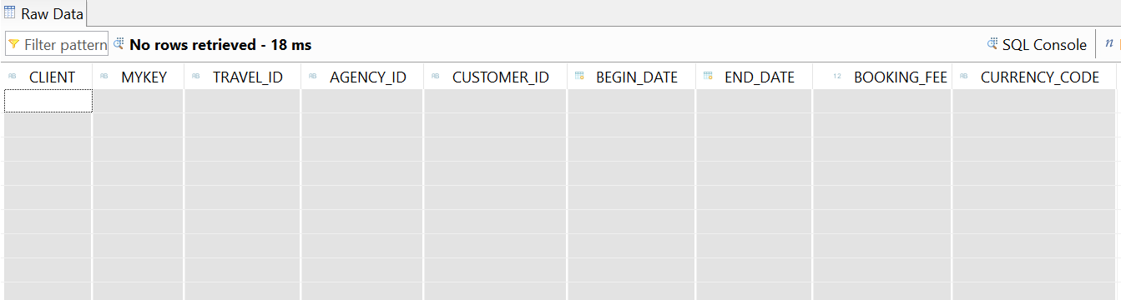

* Now the dictionary tables are defined. The dictionary tables are the basis of our travel booking data model.
* **How to create a ABAP Class:**
* Right-click on your package ZCAPG_BTP1, select New > ABAP Class.

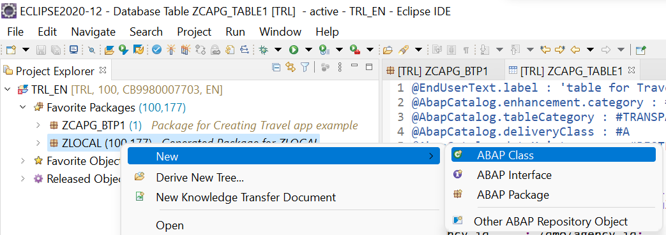

* Create a new ABAP class:
  + Name: ZCL_CAPG_TRAVEL_CLASS1
  + Description: Generating Class for travel data

Click Next >.

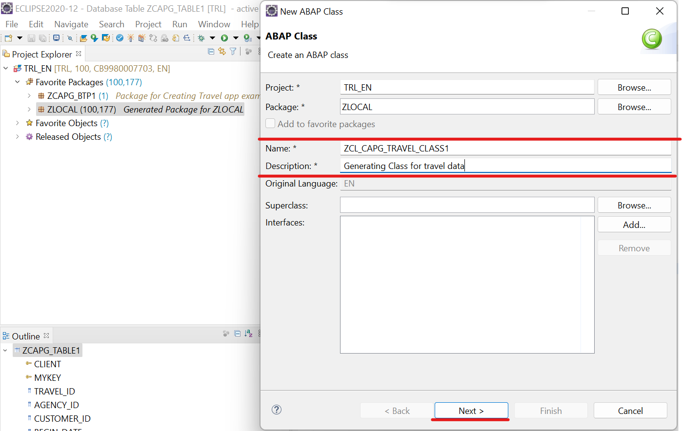

* Click Finish to create your transport request.
* Write the code for generating a class for travel data:

CLASS zcl_capg_travel_class1 DEFINITION

PUBLIC

FINAL

CREATE PUBLIC .

PUBLIC SECTION.

INTERFACES if_oo_adt_classrun.

PROTECTED SECTION.

PRIVATE SECTION.

ENDCLASS.

CLASS zcl_capg_travel_class1 IMPLEMENTATION.

METHOD if_oo_adt_classrun~main.

DATA itab TYPE TABLE OF ZCAPG_TABLE1.

* fill internal travel table (itab)

itab = VALUE #(

( mykey = '01' travel_id = '00000022' agency_id = '070001' customer_id = '000077' begin_date = '20230124' end_date = '20230128' booking_fee = '600.00' currency_code = 'USD')

( mykey = '02' travel_id = '00000106' agency_id = '070005' customer_id = '000005' begin_date = '20230304' end_date = '20230308' booking_fee = '170.00' currency_code = 'AFN')

( mykey = '03' travel_id = '00000103' agency_id = '070010' customer_id = '000011' begin_date = '20230825' end_date = '20230829' booking_fee = '170.00' currency_code = 'AFN')

).

* delete existing entries in the database table

DELETE FROM ZCAPG_TABLE1.

* insert the new table entries

INSERT ZCAPG_TABLE1 FROM TABLE @itab.

* output the result as a console message

out->write( |{ sy-dbcnt } travel entries inserted successfully!| ).

ENDMETHOD.

ENDCLASS.

* Save, activate and click F9 to run your ABAP class.
* Check your result. Therefore open your database table and press F8 to see your data. Now the dictionary tables are filled with data.

